28.31: We will travel around the loops in the counterclockwise direction.
a) 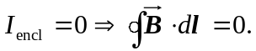
b)
c)
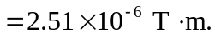
d)

Using Ampere’s Law in each case, the sign of the line integral was determined by using the right-hand rule. This determines the sign of the integral for a counterclockwise path.

